Chapter 12 Volume Worksheet Name _____________________________________
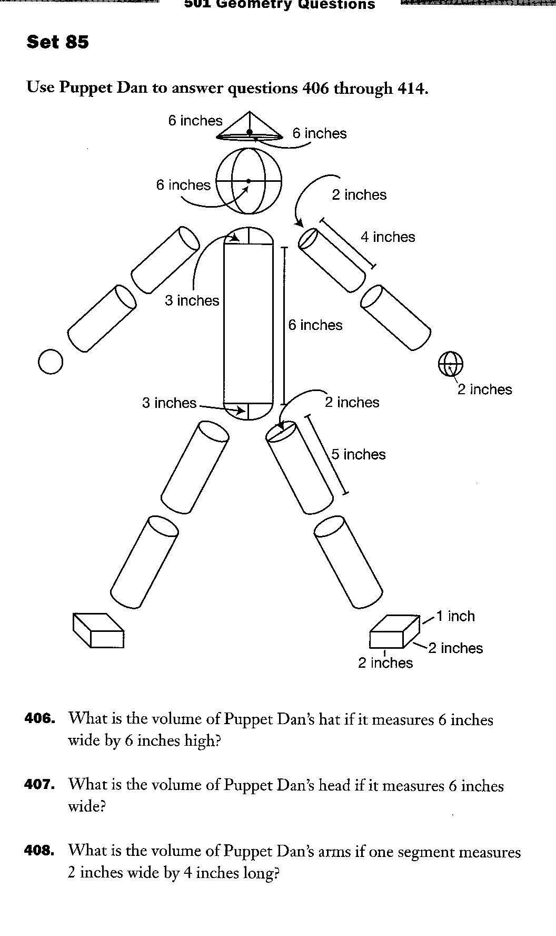
Period _____________
You must show work for each question in order to get any credit.
Use Puppet Dan to answer the following questions.

- What is the volume of Puppet Dan’s hat if it measures 6 inches wide by 6 inches high?

- What is the volume of Puppet Dan’s head if it measures 6 inches wide?

- What is the volume of Puppet Dan’s arms if one segment measures 2 inches wide by 4 inches long?

- What is the volume of Puppet Dan’s hands if each one measures 2 inches wide?

- What is the volume of Puppet Dan’s body if it measures 6 inches wide and 6 inches long? Each end of the cylinder measures 6 inches wide.

- What is the volume of Puppet Dan’s legs if each segment measures 2 inches wide by 5 inches long?

- What is the volume of Puppet Dan’s feet if each foot measures 2 inches 2 inches 1 inch?

- What is puppet Dan’s total volume?

- Puppet Dan is made out of foam. If foam weighs 3 ounces per cubic inch, how much does the total of Puppet Dan’s parts weigh?

