Name________________________ Date________________________
Areas of Trapezoids!
Find the area of the trapezoids by first finding the areas of the triangles, and then using the area addition postulate.
h
h
$$b_{1}$$
$$b_{2}$$
II
I

Area of trapezoid = Area I + Area II
Area I = Area II =
Theorem 11-5: _______________________________________________________________________________________
___________________________________________________________________________________________________.
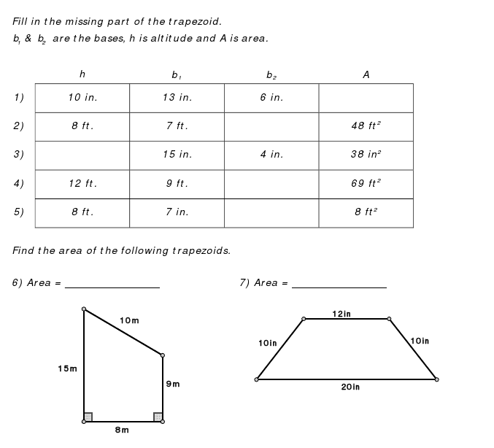
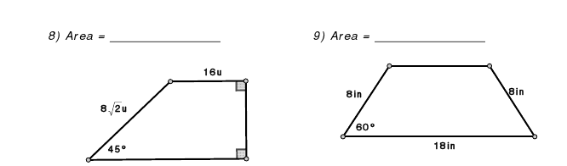
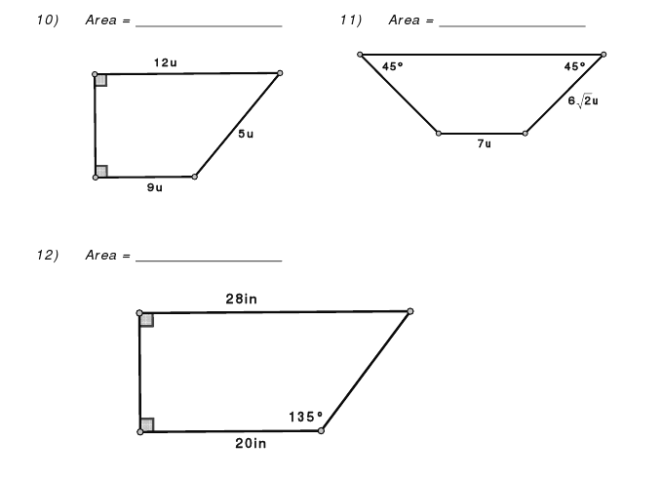
NOTE: 12u means “12 units”, i.e. “u” is NOT a variable.
- HW: pp. 436-437 2-26 even, 29, 30

