Remember, in Math the word reflect means to _______________________ a figure.

On the coordinate grid, the y-axis goes ________________ and _____________________. The x-axis goes ______________________ and __________________________.

**Example 1:** Reflecting when the line of symmetry is the x-axis.

Draw the reflection of quadrilateral ABCD over the x-axis. Name the coordinates of each vertex.

What’s the line of symmetry? __________________

A: _________ A’: _________

B: _________ B’: _________

C: _________ C’: _________

D: _________ D’: _________



**-1**

**-2**

**-3**

**-4**

**-5**

**-6**

**-7**

**-8**

**-9**

**-9 -8 -7 -6 -5 -4 -3 -2 -1 0 1 2 3 4 5 6 7 8 9**

*y-axis*

*x-axis*

**C**

**A**

**B**

**D**

**Step 5:** Connect the dots with straight lines.



**How To Perform**

**a Reflection…**

**Step 1:** Identify and **mark** the line of symmetry.

**Step 2:** Pick a point on the original figure then count the number of units from the point to the line of symmetry.

**Step 3:** Count the same number of units on the other side, from the line of symmetry to the new point.

**Step 4:** Plot the point in prime notation

**Step 6:** Check your work!



**-1**

**-2**

**-3**

**-4**

**-5**

**-6**

**-7**

**-8**

**-9**

**-9 -8 -7 -6 -5 -4 -3 -2 -1 0 1 2 3 4 5 6 7 8 9**

*y-axis*

*x-axis*

**V**

**T**

**U**

**You Try 1!**

Draw the reflection of triangle TUV over the x-axis. Name the coordinates of each vertex.

T: _________ T’: _________

U: _________ U’: _________

V: _________ V’: _________

**Example 2:** Reflecting when the line of symmetry is the y-axis.



**-1**

**-2**

**-3**

**-4**

**-5**

**-6**

**-7**

**-8**

**-9**

**-9 -8 -7 -6 -5 -4 -3 -2 -1 0 1 2 3 4 5 6 7 8 9**

*y-axis*

*x-axis*

**X**

**Y**

**Z**

Draw the reflection of triangle XYZ over the y-axis. Name the coordinates of each vertex.

What’s the line of symmetry? _____________________

X: _________ X’: _________

Y: _________ Y’: _________

Z: _________ Z’: _________



**-1**

**-2**

**-3**

**-4**

**-5**

**-6**

**-7**

**-8**

**-9**

**-9 -8 -7 -6 -5 -4 -3 -2 -1 0 1 2 3 4 5 6 7 8 9**

*y-axis*

*x-axis*

**D**

**A**

**B**

**C**

**You Try 2!**

Draw the reflection of quadrilateral ABCD over the y-axis. Name the coordinates of each vertex.

A: _________ A’: _________

B: _________ B’: _________

C: _________ C’: _________

D: _________ D’: _________

**Example 3:** Reflecting when the figure overlaps the line of symmetry



**-1**

**-2**

**-3**

**-4**

**-5**

**-6**

**-7**

**-8**

**-9**

**-9 -8 -7 -6 -5 -4 -3 -2 -1 0 1 2 3 4 5 6 7 8 9**

*y-axis*

*x-axis*

**V**

**T**

**U**

Draw the reflection of triangle TUV over the y-axis. Name the coordinates of each vertex.

What’s the line of symmetry? _____________________

T: _________ T’: _________

U: _________ U’: _________

V: _________ V’: _________

**You Try 3!**

Draw the reflection of triangle TUV over the x-axis. Name the coordinates of each vertex.

T: _________ T’: _________

U: _________ U’: _________

V: _________ V’: _________



**-1**

**-2**

**-3**

**-4**

**-5**

**-6**

**-7**

**-8**

**-9**

**-9 -8 -7 -6 -5 -4 -3 -2 -1 0 1 2 3 4 5 6 7 8 9**

*y-axis*

*x-axis*

**V**

**T**

**U**

What are some common **BLUNDERS** on these types of problems?

**Think about it…**

AH-HA!

**If you have a figure in quadrant 1…**

…and you reflect over the x-axis the image will be in quadrant ______________.

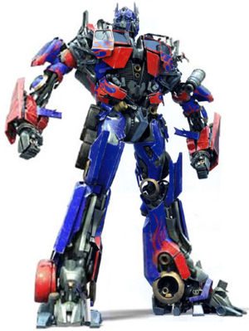…and you reflect over the y-axis the image will be in quadrant ______________.

**If you have a figure in quadrant 2…**

…and you reflect over the x-axis the image will be in quadrant ______________.

…and you reflect over the y-axis the image will be in quadrant ______________.

**If you have a figure in quadrant 3…**

…and you reflect over the x-axis the image will be in quadrant ______________.

…and you reflect over the y-axis the image will be in quadrant ______________.

**If you have a figure in quadrant 4…**

…and you reflect over the x-axis the image will be in quadrant ______________.

…and you reflect over the y-axis the image will be in quadrant ______________.

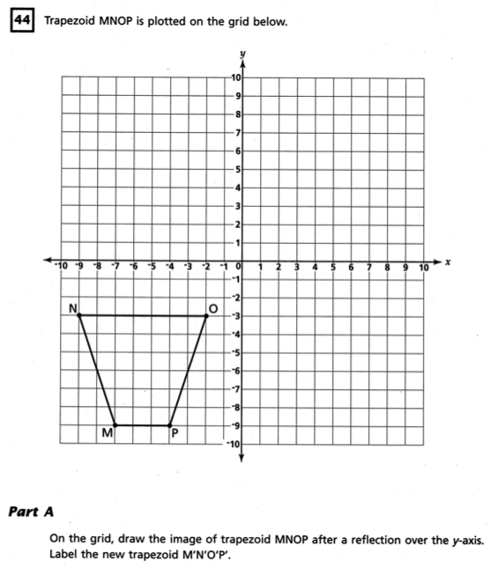**2007 8th Grade State Exam Book 3 Question:**

***Part B***

On the lines below, explain how you determined the location of point M’.

**Independent Practice**

**2.**

**1.**

**3.**



**-1**

**-2**

**-3**

**-4**

**-5**

**-6**

**-7**

**-8**

**-9**

**-9 -8 -7 -6 -5 -4 -3 -2 -1 0 1 2 3 4 5 6 7 8 9**

*y-axis*

*x-axis*

Draw the reflection of triangle XYZ over the x-axis. Name the coordinates of each vertex.

X: _________ X’: _________

Y: _________ Y’: _________

Z: _________ Z’: _________

**X**

**Y**

**Z**



**-1**

**-2**

**-3**

**-4**

**-5**

**-6**

**-7**

**-8**

**-9**

**-9 -8 -7 -6 -5 -4 -3 -2 -1 0 1 2 3 4 5 6 7 8 9**

*y-axis*

*x-axis*

Draw the reflection of quadrilateral ABCD over the y-axis. Name the coordinates of each vertex.

A: _________ A’: _________

B: _________ B’: _________

C: _________ C’: _________

D: _________ D’: _________

**D**

**A**

**B**

**C**



**-1**

**-2**

**-3**

**-4**

**-5**

**-6**

**-7**

**-8**

**-9**

**-9 -8 -7 -6 -5 -4 -3 -2 -1 0 1 2 3 4 5 6 7 8 9**

*y-axis*

*x-axis*

Draw the reflection of triangle TUV over the x-axis. Name the coordinates of each vertex.

T: _________ T’: _________

U: _________ U’: _________

V: _________ V’: _________

**V**

**T**

**U**

5.

4.



**-1**

**-2**

**-3**

**-4**

**-5**

**-6**

**-7**

**-8**

**-9**

**-9 -8 -7 -6 -5 -4 -3 -2 -1 0 1 2 3 4 5 6 7 8 9**

*y-axis*

*x-axis*

Draw the reflection of quadrilateral ABCD over the x-axis. Name the coordinates of each vertex.

A: _________ A’: _________

B: _________ B’: _________

C: _________ C’: _________

D: _________ D’: _________

**C**

**A**

**B**

**D**



**-1**

**-2**

**-3**

**-4**

**-5**

**-6**

**-7**

**-8**

**-9**

**-9 -8 -7 -6 -5 -4 -3 -2 -1 0 1 2 3 4 5 6 7 8 9**

*y-axis*

*x-axis*

Draw the reflection of triangle TUV over the y-axis. Name the coordinates of each vertex.

T: _________ T’: _________

U: _________ U’: _________

V: _________ V’: _________

**V**

**T**

**U**

**6.**



**-1**

**-2**

**-3**

**-4**

**-5**

**-6**

**-7**

**-8**

**-9**

**-9 -8 -7 -6 -5 -4 -3 -2 -1 0 1 2 3 4 5 6 7 8 9**

*y-axis*

*x-axis*

Draw the reflection of triangle XYZ over the y-axis. Name the coordinates of each vertex.

X: _________ X’: _________

Y: _________ Y’: _________

Z: _________ Z’: _________

**X**

**Y**

**Z**

**Homework: WB pg. 112 all.**

**Exit Ticket**

Draw the reflection of quadrilateral ABCD over the x-axis. Name the coordinates of each vertex.

A: _________ A’: _________

B: _________ B’: _________

C: _________ C’: _________

D: _________ D’: _________



**-1**

**-2**

**-3**

**-4**

**-5**

**-6**

**-7**

**-8**

**-9**

**-9 -8 -7 -6 -5 -4 -3 -2 -1 0 1 2 3 4 5 6 7 8 9**

*y-axis*

*x-axis*

**X**

**Y**

**Z**



**-1**

**-2**

**-3**

**-4**

**-5**

**-6**

**-7**

**-8**

**-9**

**-9 -8 -7 -6 -5 -4 -3 -2 -1 0 1 2 3 4 5 6 7 8 9**

*y-axis*

*x-axis*

**D**

**A**

**B**

**C**

Draw the reflection of triangle XYZ over the y-axis. Name the coordinates of each vertex.

X: _________ X’: _________

Y: _________ Y’: _________

Z: _________ Z’: _________