9-3 Arcs and Central Angles Name _______________________________________
Period __________________
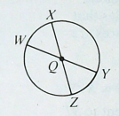
Using the letters shown in the diagram, name:
- Four central angles
- Two semicircles
- Four minor arcs
- Four major arcs
