Name________________________
Date________________________
Dissecting a Circle!
Directions: Compare and contrast the pictures of the circles to fill in the blanks of the definitions for the terms below. (The first few terms have already been given to you)
e
.
A
h
f
a
X
W
S
O
I
H
F
g
d
Y
R
P
J
G
.
.
.
b
V
L
K
E
C
B
i
c
U
Q
N
M
D
T
Circle: A circle is the set of points in a plane at a given distance from a given point in that plane. The given point is the center of the circle. The given distance is the radius.
Center: Points F, E, O, P, Q, and “g” are NOT center points. Points B, K, R, and “b” ARE center points.
Radius: Segments AC, OP, XY, and “ac” are NOT radii (plural). Segments BC, KL, RS, and “bc” ARE radii.
In the circles below, draw your own chords, secants, diameters, tangents, and points of tangency!
1. Chord: Segments AB, JK, QR, and “ab” are NOT chords.
Segments AC, DE, OP, VW, XY, “fg” and “hi” ARE chords.
A chord is a _________ whose endpoints ____ on a circle.
2. Secant: Lines HI, MN, TU, and “de” are NOT secants.
Lines DE, OP, VW, and “fg” ARE secants.
A secant is a ______ that contains a __________.
3. Diameter: Segments FG, MN, UT, and “fg” are NOT diameters.
Segments AC, JL, QS, and “ac” ARE diameters.
A diameter is a _______ that contains the _________ of a circle.
4. Tangent: Lines DE, OP, VW, and “fg” are NOT tangents.
Lines HI, MN, TU, and “de” ARE tangents.
A tangent is a ______ in the plane of a circle that intersects the circle in exactly _____ point(s).
5. Point of tangency: Points A, B, M, R, Q, and “c” are NOT points of tangency. Points H, N, U, and “d” ARE points of tangency.
The point of tangency is the point where the ________ line and the _________ intersect at exactly ______ point(s).
[Label a point of tangency on the tangent line that you created.]

Directions: Once again, compare and contrast the pictures of the circles to fill in the blanks of the definitions for the terms below.
NONE of these circles are congruent.
These two circles are congruent.
8
3
These two circles are congruent.
.
.
4
.
.
6
5
6
.
.
.
4

6. Congruent circles: Congruent circles are circles that have congruent ____________.
These two circles are NOT concentric.
These three circles are concentric.
These two circles are concentric.
.
These two circles are NOT concentric.

7. Concentric circles: Concentric circles are circles that lie in the same plane and have the same ________________.

8. Inscribed and Circumscribed: A polygon is inscribed in a circle and the circle is circumscribed about the polygon when each ___________ of the polygon lies on the circle.
What about Spheres?
9. Sphere: A sphere with center O and radius r is the set of all points in space at a distance r from point O.
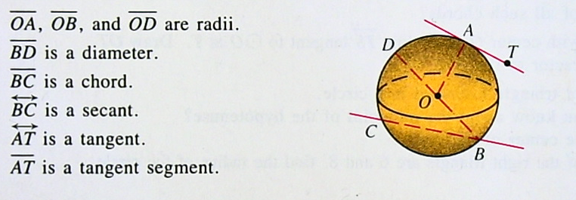
10. Concentric spheres: Concentric spheres are spheres that have the same ___________. [Compare to concentric circles.]
CW: pg. 330 #1-8, 10, 11 HW: pg. 330-331 #2-18 even

