Formative Assessment Analysis
- Select 1 of the assessments used in your 2-day benchmark lesson and modify the appropriate content rubric to score the assessment. Check

- Use the rubric to analyze the student work.
  - In detail, describe how the students responded to the assessment and their performance.
  - Include samples of student work (i.e. cut-and-paste or describe). Need 5 samples!
After analyzing the student assessments from day one of the PBI 2 Day lesson, I see that I have students with answers that range from level 1 to level 5 (extended abstract). I had one student who only had stuff written down to turn in because I helped him. The day of the lesson when students were to answer the question he only had a hexagon on his paper, he had no given values written down. I helped him through the problem, having him write the given values and write the area formula we had just developed during the lesson. (Which he looked back to his notes page for). So if I take myself and my assistance out of the picture, I had one students who had no clue of how to go about the problem, I would rate him a level 0. I had 1 student who I would rate a level 1, he drew a picture, labeled the given information and wrote, “ You need to find the number of sides, radius, length of side. Number of sides = 6. Radius = .” I am not sure if he ran out of time or what, but simply based on the work turned in I see that he know the parts of information he needs to find the area, however there is no proof that he knows how to apply the information. I did not have any transitional students by the way the rubric defines it explicitly, however I do think she would qualify as transitional, because she was not a level one or a level three. She differed from the description of transitional because she did find the values to get the perimeter, however she did not show that she knew to set (1/2)(16/2/3)(6)(8) equal to the given area (400). Again, I don’t know if she just ran out of time or what, she does have written “a = (1/2) (ans)” but she never plugged in 400 for her a (area). My next category that I identified had one student who showed that she tried applying both versions of the formula, A = (1/2)asn and A = (1/2)ap. This stood out to me because most students went directly for the A = (1/2)asn formula. She however first tried finding the perimeter by multiplying the side length by the number of sides of the polygon. However, she did not find a value for the perimeter; instead she jumped to the other version of the formula and plugged in the given values to arrive at 400. A majority of my students fell in the analytical category. All but 7 followed the description as it is described. I guess they didn’t see the word “Explain.” At the end of the task. As mentioned before, all the students used the A = (1/2)asn version of the formula, plugged in their given information and set it equal to 400. Then they were done. There were no written words on their paper. I had 4 students who reached the extended abstract level of the rubric when answering the formative assessment question. Not only did they show mathematically that the two sides were equal, they then explained in words what they did. How they got the values they did and in what way they are to be applied to one another.

- Using the results of your rubric analysis and the following questions as a guide, reflect on the nature of student understanding that is captured with this assessment.
  - Were you surprised at how the students performed?
  - Citing specifics from the results of your analysis, what new things have you learned about the thinking patterns of the students that you didn’t know beforehand?
I was not surprised by how the students performed. They did as I would have hoped they would. A majority did a fair job and my A+ students came through and answered the question completely, i.e. explain their process as asked. I have learned that students may think that the two formulas are different and there was only one correct one to be applied in this problem. I have also learned that students ignore the word “explain”. I don’t know what to do to make sure that they explain their work besides looking for words on their paper when they try to turn it in. If it does not have an explanation I could send them back to add one. However in this case, there was no time for that. As mentioned in the earlier response, I think that a few of the students might have been rushed with this question and therefore where not able to show all that they could do.

- Explain how the results of this assessment will inform your future instruction to address the needs of students.
  - Discuss the instructional implications stemming from the assessment (i.e., how will the results alter the way that you would teach the class now that you have more information about how they think?)
  - Discuss specific revisions you would make to the 2-day lesson and include what you have learned in the analysis of the assessment.
In the future when teaching this I will have more time to go through and not rush the explain portion of the lesson. The students were doing so well with the explore I didn’t want to stop them so I let them continue and in turn ran short on time for the explanation. I think giving more time to the explanation, I could make sure students see why and understand that the two formulas are indeed the same. I think allowing more time on the explain would provide us all the opportunity to hear all that was discovered in the explore section of the lesson. I had students that could come to the board and show that finding the area of 6 congruent triangles would give them the same result. I would want students to see all the relationships involved and what we mean when we say that sn and p are the same thing. So to sum it up, I would keep the lesson how it was designed, just allow more time for the explain portion. (I think in the actual write up of the lesson the allotted time would have been enough, just the time allowed in the class due to going over homework and administrative tasks, I was unable to follow the timeline.) A larger change, outside of just teaching this lesson for two days would be to have my students writing more in math. I love the idea of having them write in composition books to explain to someone the concept they are learning. I think if students began this practice at the beginning of the school year, they would be trained, if you will, to provide a couple sentence explanation on a problem like this where it asks them to explain. This would be something that is set up earlier in the year, not just for this lesson.

Level 5:

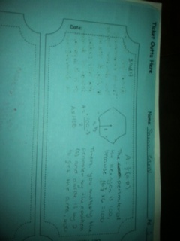

Level 4:

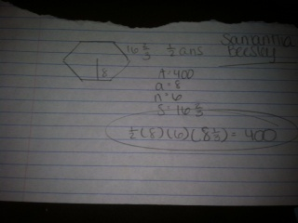

Level 3:
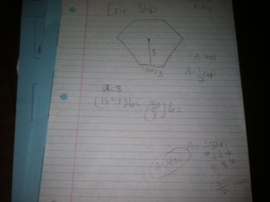

Level 2:
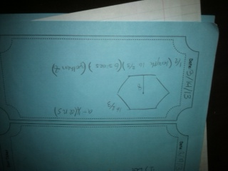

Level 1:
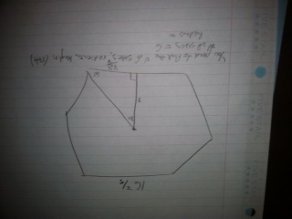

Levels | Explanation of the levels | Typical student responses at each level of reasoning on the best concert tour task
Extended abstract | Students generalize the structure to make it new and more abstract. | They identify the formula A=1/2aP or A=1/2sna. They recognize the given information in the problem as pieces of the formula. Substitute 400 in for A and 8 for a. Students will construct the formula with the given pieces substituted in correctly. 400=1/2(8)p or 400=1/2(8)sn. Students make the connection that a regular hexagon has six congruent sides. Each side has a length of 16 2/3, given information. Students will need to make the connection that they need to use these pieces to find the perimeter of the regular hexagon. They accurately multiply to show that the formula holds true. Explain that they need to apply the formula for finding the area of polygons.
Analytical | Students integrate the ideas to create a meaningful structure. | They identify the formula A=1/2aP or A=1/2sna. They recognize the given information in the problem as pieces of the formula. Substitute 400 in for A and 8 for a. Students will construct the formula with the given pieces substituted in correctly. 400=1/2(8)p or 400=1/2(8)sn. Students make the connection that a regular hexagon has six congruent sides. Each side has a length of 16 2/3, given information. Students will need to make the connection that they need to use these pieces to find the perimeter of the regular hexagon. They accurately multiply to show that the formula holds true.
Quantitative | Students can identify mathematical ideas in a quantitative way but cannot integrate these mathematical ideas during the task. | They identify the formula A=1/2aP or A=1/2sna. They recognize the given information in the problem as pieces of the formula. Substitute 400 in for A and 8 for a. Students will construct the formula with the given pieces substituted in correctly. 400=1/2(8)p or 400=1/2(8)sn. They say they need more information and cannot find the perimeter and therefore cannot solve the problem.
Transitional | Students focus on only one aspect of the solution. | They identify the formula A=1/2aP or A=1/2sna. They recognize the given information in the problem as pieces of the formula. Substitute 400 in for A and 8 for a. Students will construct the formula with the given pieces substituted in correctly. 400=1/2(8)p or 400=1/2(8)sn. The students stop at that point not recognizing that they need to find perimeter.
Idiosyncratic | This level is based on subjective reasoning with unrelated data and is affected by subjective beliefs and personal experiences. | Students recognize that they need to use the area formula and the given values but do not know how to apply them appropriately.

