**Lesson 2 – Section 4.1 Triangle Sum Conjecture & 4.2 Properties of Isosceles Triangles**

**Creator:** Heather McNeill

**Grade:** 10th grade

**Course:** Geometry Honors

**Length:** 50 minutes

**1.** **Prior Knowledge, Skills, and Dispositions:** In this lesson, students should already have an understanding about triangle properties since they learned about triangles in section 1.5, however in this lesson we will formally cover the Triangle Sum Conjecture, the sum of the measures of the angles in every triangle is 180º. From there students will be guided through discovery to learn about the properties of isosceles triangles and the Isosceles triangle Conjecture. To be successful in this lesson, students must know how to measure angles using a protractor.

**2.** **Academic Content Standards:**

|  |  |
| --- | --- |
| **Benchmark** | **Description** |
| MA.912.G.4 | Identify and describe various kinds of [triangles](javascript:;) (right, acute, scalene, isosceles, etc.). Define and construct [altitudes](javascript:;), [medians](javascript:;), and [bisectors](javascript:;), and [triangles](javascript:;) [congruent](javascript:;) to given [triangles](javascript:;). Prove that [triangles](javascript:;) are [congruent](javascript:;) or similar and use properties of these [triangles](javascript:;) to solve problems involving [lengths](javascript:;) and areas. Relate [geometry](javascript:;) to algebra by using [coordinate](javascript:;) [geometry](javascript:;) to determine regularity, congruence, and [similarity](javascript:;). Understand and apply the [inequality](javascript:;) [theorems](javascript:;) of triangles. |
| MA.912.G.4.1 | Classify, construct, and describe [triangles](javascript:;) that are right, acute, obtuse, scalene, isosceles, equilateral, and equiangular. |
| MA.912.G.8 | In a general sense, mathematics is problem solving. In all mathematics, use problem-solving skills, choose how to approach a problem, explain the reasoning, and check the results. At this level, apply these skills to making conjectures, using [axioms](javascript:;) and [theorems](javascript:;), constructing logical arguments, and writing geometric [proofs](javascript:;). Learn about inductive and deductive reasoning and how to use [counterexamples](javascript:;) to show that a general statement is false. |
| MA.912.G.8.1 | Analyze the structure of [Euclidean geometry](javascript:) as an axiomatic system. Distinguish between undefined terms, definitions, [postulates](javascript:), and [theorems](javascript:). |
| MA.912.G.8.3 | Determine whether a solution is reasonable in the context of the original situation. |

- Students will be able to explain that the sum of the measures of the angles of a triangle is always 180°.

- Students will be able to describe a relationship related to the base angles of an isosceles triangle and make a conjecture about triangles that have two congruent angles.

- Students will be able to show problem solving skills and inductive reasoning skills as well as the implementation of new vocabulary.

**3.** **Description of Pedagogy:** The lesson will be taught using a variety of techniques. Parts of the lesson will include independent work, small group and whole class discussions. These techniques will work fine for George; he has no problem working well with other male students, whom he already sits around and will be grouped up with.

**4. Assessment:** During the lesson, I will walk around the room monitoring students’ progress, making sure each student is on task and participating in the task. During each section of the lesson I will ask the students to explain what they have found. From the student answers I should be able to judge where their level of understanding is and whether or not I should proceed onto the next section. I am looking to see that they understand that no matter what type of triangle they have the sum of the angle measures will always be 180º as well as properties of isosceles triangles; specifically, characteristics about congruent sides and congruent angles. Once the lesson is complete I will assign the corresponding homework problems. (Section 4.1 # 2-12 even, 16, 20-25 and 4.2 #2-10 even, 14 – 24 even) The questions they ask in class and the answers they give me through class discussion, as well as answers in reviewing their homework which will be returned the following class period. The work they show in answering the homework problems will help me in understanding what the students left the lesson knowing.

**5. Detailed Lesson Sequence:**

|  |  |  |
| --- | --- | --- |
| **What the teacher will do:** | **Statements/Questions the teacher will say/ask:** | **Possible student responses:** |
| **Warm-Up 7 minutes** | | |
| Pass out worksheet titled Lesson Terminology and put the matching transparency on the overhead.  Allow the students 5-7 minutes to fill in their 3 words.  On overhead go over the 3 words. (3-5 minutes) | Please come in sit down and begin filling out the paper on your desk. You may use your book, and some of these terms may seem familiar to you.  Be sure you also come up with an example or a picture that represents your description. This should help you in remembering what the words mean. | N/A |
| **Engagement 5 minutes** | | |
| Today we are going to focus on some properties of triangles.  Ask students for real-world applications of triangles.  After hearing some examples from students place the transparency of real-world triangle examples on the overhead.  Tie together the terms on the front of the paper with the real-world images on the back.  Have a class discussion pertaining to what the students found. | To begin, raise your hand if you would like to share an example of a triangle outside of the classroom.  Here are some examples I thought of, we have an electrical grid tower, trusses on a roof, a pennant, pyramids, a Dorito, the sails on a sail boat, a triangular shaped house, and another type of truss used in sound and stage equipment.  At this time please find and at least one of each type of triangle listed on the front side of the paper. (An acute, a right and an obtuse triangle.) I would like for you to outline or shade it in and classify which type of triangle it is.  In real life, outside of this class do you walk around and see angles marked as ninety degrees, or that they are congruent? We must use reasonable judgment.  Raise your hand to share with the class which picture you chose for each type of triangle. | Varied student answers.  *But how can we assume it is a right angle?*  Varied student answers. |
| **Triangle Sum Conjecture 15 minutes** | | |
| Inform the class what we will be doing.  Instruct the class on the next task. Place the transparency with the step by step directions and example on the overhead.  Pass out protractors.  Pass out a set of six colored triangles to each group.  Wander around the classroom making sure all students are participating.  Get the students’ attention back at the front of the classroom. Discuss the student findings.  Instruct the students on the next step of the investigation.  Place the example transparency on the overhead.  Discuss the Triangle Sum Conjecture.  Formally state what the Triangle Sum Conjecture is. | Now we will look at the angle measures of triangles.  For this activity you will be in groups of three so those tables not in threes already, please move to make a group of three. I am going to pass out a set of six triangles to your group. Each person is going to measure their two triangles using a protractor and write the angle measure in that corner, followed by the sum of the angles and its classification in the center. (See there are two blue triangles, two yellow triangles and two red triangles. The classification will be one of the three terms from your warm up.) Once you have done this you will switch a colored pair of triangles with someone else in your group and they will double check that everything you wrote down is correct.  Who can share with the class what we are going to be doing?  And what are the possible types of triangles we can have?  Raise your hand if you need a protractor.  Be sure you are discussing your findings with all members of your group.  Raise your hand to share with the class some things you noticed.  Did the type of triangle matter?  Why or why not?  Anything else anyone wants to add?  Now what you’re going to do is switch colors one last time, you should have the one color you haven’t had yet. *Carefully* tear off the three angles of the triangle and arrange them so that their vertices meet at one point.  How does this arrangement verify the angle sum you found initially?  Is this a linear pair? Why or why not?  Is this supplementary? Why or why not?  So knowing this, who wants to state in words what they think the Triangle Sum Conjecture might be? | Student repeats directions.  *Acute, Right, Obtuse.*  *All the triangles summed to 180º. There were two examples of each type of triangle, acute, obtuse, and right.*  *No, no matter the type of triangle, the three angle measures will always sum to 180º.*  *When we put all three vertices together we see that the pieces form a straight line. We know that a straight line measures 180º.*  *No, because a linear pair is composed of a pair, two, angles and this is composed of three.*  *No, because once again, supplementary angles are composed of two angles, we have three.*  *The sum of the measures of the angles in every triangle is180º.* |
| **Properties of Isosceles Triangles 20 minutes** | | |
| Now we are going to move on to discuss properties of isosceles triangles.  Pass out the handout with the 3 isosceles triangles on it.  Question students on parts of an isosceles triangle.  Instruct students to measure the missing angles. Discuss the findings.  Discuss the angles found.  Formally state what the Isosceles Triangle Conjecture is.  Formally state what the Converse of the Isosceles Triangle Conjecture is.  Show students an example with one of the isosceles triangles from their paper on the overhead. | Please raise your hand if you would like to define what an isosceles triangle is?  Just from looking at these triangles what do we know? What do you notice?  What does that tell us?  Okay, you said they all sum to 180º, and what conjecture tells us that?  What are the names of the two missing angles?  What is the name of the angle that was given to you? How do you know that is the vertex angle?  As a group, measure the missing angles on the paper. What do you notice? (They are congruent.)  Did you expect that? Why or why not?  Could we have a triangle with two right angles? Why or why not?  But we could have a triangle with more than one obtuse angle, right? (Not really!) Why or why not?  So have 27º, 27º, 45º, 45º, 69º and 69º. Think about these angle measures. What is common between the base angles from all three triangles?  Why is that?  What can we conclude from this investigation?  Based on that conjecture, is an equilateral triangle an isosceles triangle? Why or why not?  So what would the converse of this conjecture be? Well first off, what is a converse?  Is the converse true?  If a triangle has two congruent angles, does that automatically make it an isosceles triangle? Why do you say that?  How could be check to be sure?  Well if we take our compass and measure the lengths of the sides, what are we checking for?  Thus, what have we found? | *An isosceles triangle is a triangle with* ***at least*** *two congruent sides. The angle between the congruent sides is called the vertex angle. The other two angles are called the base angles. The side between the base angles is called the base. The other two sides are called the legs.*  *We have three different types of triangles, acute, right and obtuse, and they all three have two congruent sides. They all sum to 180º.*  *Triangle Sum Conjecture.*  *The base angles.*  *The vertex angle. It is the angle between the two congruent sides.*  Varied student answers.  Varied student answers.  *No, because then our other angle would have to be 0º by the triangle Sum Conjecture and we wouldn’t have a triangle.*  *No, because then the sum of our three angles would be great than 180º. (Similar to the previous question.)*  *They are all acute.*  *If they were right or obtuse our three angles would sum to more than 180º. Therefore, the two congruent angles must be acute.*  *That no matter whether the triangle is acute, right or obtuse, if it is isosceles, then its base angles are congruent.*  *If a triangle is isosceles, then its base angles are congruent.*  *Yes, because an equilateral triangle has three congruent angles, thus its two base angles are congruent.*  *With an if-then statement we check to see if the statement holds both forwards and backwards.*  Varied student answers. *If a triangle has two congruent angles, then it is an isosceles triangle.*  *Yes/No.* Varied student explanations.  Varied student answers.  *That the side lengths are the same length.*  *That the converse is true, if a triangle has two congruent angles, then it is an isosceles triangle.* |
| **Wrap-Up 3 minutes** | | |
| Your homework for tonight is Section 4.1 # 2-12 evens, 16, 20-25  Section 4.2 # 2-10 evens, 14-24 evens  Turn the class over to Dr. Allison to release them to lunch. |  |  |

* + - 1. **Materials:** Pencil, protractor, Discovering Geometry textbook, blank transparencies, overhead markers, student worksheets, printed transparencies, compass
      2. **Resources*:**

<http://www.mathwarehouse.com/geometry/triangles/interactive-triangle.htm>

<http://www.mathopenref.com/isosceles.html>

<http://www.keymath.com/x19410.xml>

* + - 1. **Lesson Starter:** See attached PDF. It is the pages from the teacher edition in their textbook (section 4.1 & 4.2).

(The student worksheets have a spot for the student’s name, just not on here (below) because I copied and pasted these from the originals where the ‘name’ line is in the header. Also some of the worksheets and transparencies are in landscape format but to include everything in this one document I changed them to portrait.)

**Lesson 4.1 & 4.2 Terminology**

|  |  |  |
| --- | --- | --- |
| **Term** | **Description** | **Example/Picture** |
| Acute  Triangle |  |  |
| Right Triangle |  |  |
| Obtuse  Triangle |  |  |

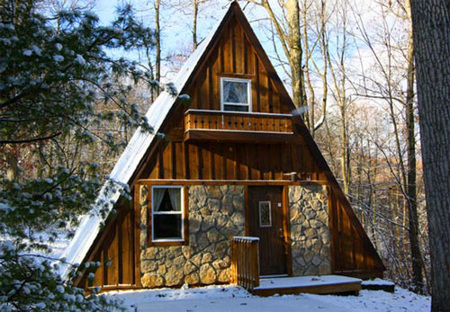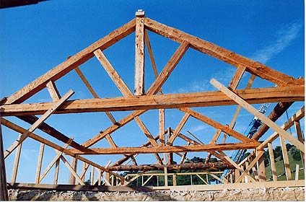

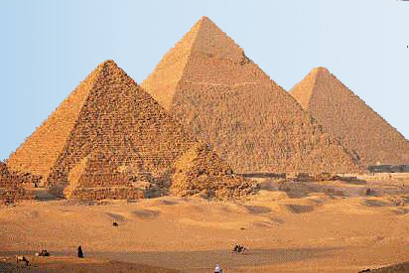

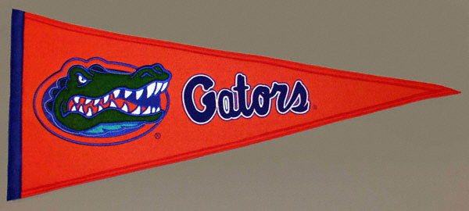

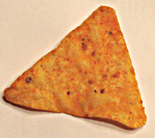

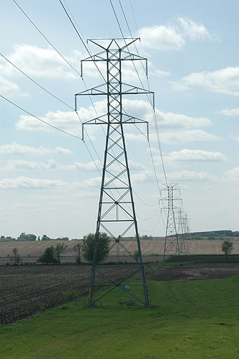

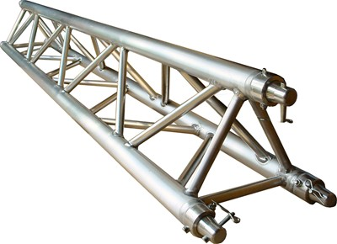

1. Measure each angle using a protractor and write the angle measure in the angle.

2. Write the sum of the three angles in the center.

3. Classify each triangle as either an acute, obtuse or right triangle.

180º

Acute

60º

60º

60º

____________________

____________________

____________________

____________________

____________________

____________________

____________________

____________________

____________________

____________________

____________________

____________________

____________________

____________________

____________________

____________________

________________

________________

________________

________________

________________

________________

________________

________________

________________

________________

________________

________________

________________

________________

________________

________________

____________

_____________

____________

_____________

____________

_____________

____________

_____________

____________

_____________

____________

_____________

____________

_____________

____________

_____________

__________________

__________________

__________________

__________________

__________________

__________________

__________________

__________________

__________________

__________________

__________________

__________________

__________________

__________________

__________________

__________________

_________

_________

_________

_________

_________

_________

_________

_________

_________

_________

_________

_________

________

________

________

________

__________________

__________________

__________________

__________________

__________________

__________________

__________________

__________________

__________________

__________________

__________________

__________________

__________________

__________________

__________________

__________________

The Triangle Sum



How does this arrangement verify the angle sum you found initially?

**Isosceles Triangle**

**Vertex angle**

**Legs**

**Base**

**Angles**

**Base**

Triangle Properties

From Sections 4.1 & 4.2

In your own words, state the following conjectures and draw a picture to express each statement.

1. **Triangle Sum Conjecture –**

Picture:

2. **Isosceles Triangle Conjecture –**

Picture:

3. **Converse of the Isosceles Triangle Conjecture –**

Picture: