Fill in the blanks.
1.) Parallel lines have _____________ slopes.
2.) Perpendicular lines have ___________________________________ slopes.
Write the opposite reciprocal for each of the following values.
3.) 3 4.) $\frac{1}{2}$ 5.) -5 6.) - $\frac{2}{3}$ 7.) - $\frac{17}{1}$
Determine whether each pair of equations is parallel, perpendicular or neither.
8.) y = - 6x + 8 3x + ½y = -3
9.) y = - ¼x -3 2y – 12x = 10
10.) y = 3x – 4 3y – 9x = 12
Write an equation in slope-intercept form for the line that passes through the given point and is parallel to the given equation.
11.) ( -4, 3 ) y = ½x - 6 12.) ( -1, 1 ) x - 3y = – 4

Write an equation in slope-intercept form for the line that passes through the given point and is perpendicular to the given equation.
13.) ( 2, 3 ) y = ¼x – 4 14.) ( -1, -6) x + 6y = 6

Fill in the blanks.
15.) The 3 possible correlations for scatter plots are: _______________, ________________, ______________.
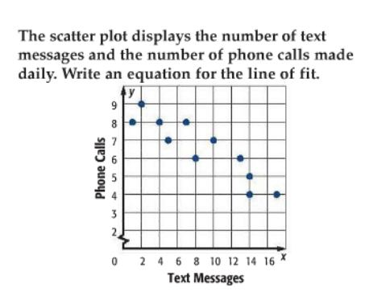
16.) A line of fit - __________________________________________________________________________.
17.) Describe the correlation and what the scatter plot tells us.

18.) Draw a line of fit and write its equation.

19.) What might be the outcome when 20 text messages are sent?

