A linear equation is:
__________________________________________________________________________________________
Draw an equation on the Draw an equation on the graph
graph that is linear. that is not linear.

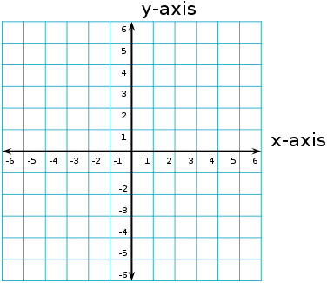

Standard Form: _______________________________

3 things to remember about Standard form:

- _________________________________________________________________

- _________________________________________________________________

- _________________________________________________________________

An example of a linear equation is: __________________ In standard form it looks like: __________________

An intercept is: _____________________________________________________________________________

Remember:
- All linear equations have _____________________
one x- and y- intercept. Unless it is the equation
___________________ or __________________

- Linear equations may not always have
__________________________________________
X | Y
-2
-1
0
1
2
3
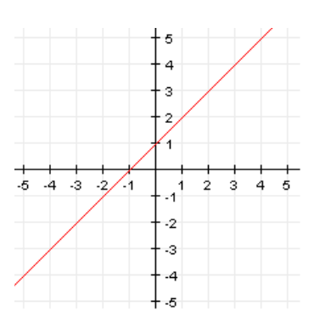
y = x + 1

x-intercept:

Ordered pair at the x-intercept:

y-intercept:

Ordered pair at the y-intercept:

How can we find the intercept(s) of y = 13x – 6?

Let’s think about 2x + 4y = 16. Is this equation is standard form?

Standard form of this equation is:

I will find the intercept(s) of 2x + 4y = 16 by: Once you know the intercept(s)
graph the equation using the two
graph of equation table of values plugging in 0 intercepts.

Remember: We can find intercepts 3 different ways. Some techniques are easier than others depending on the equation. The 3 ways are:

