Vocabulary Term | Definition | Picture/Description
Bivariate Data

Scatter Plot

Correlation

Line of Fit

Linear Interpolation

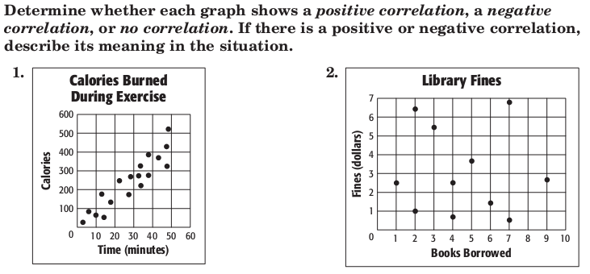

Steps for Scatter Plots:

- Make a _______________________________ .
Determine whether any ___________________ exits in the data.

- Draw a ___________ that passes close to most of the ______________________________ .

- Use two _____________ on the ____________________________ to write an equation for the line.
4.) Use a ________________________________ to make ___________________________ .

Songs Bought | 0 | 1 | 3 | 5 | 7 | 9 | 12
Cost ($) | 0 | 1 | 2 | 6 | 9 | 9 | 10
Example: iTunes Downloads

Type of correlation:
Two points on the line of fit:
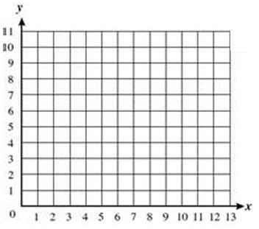
Make predictions:
Meaning of the correlation:
Equation of line of fit:

