Remember, in Math the word translate means to _______________________ a figure.

**Example 1:** Describe the translation.



**-1**

**-2**

**-3**

**-4**

**-5**

**-6**

**-7**

**-8**

**-9**

**-9 -8 -7 -6 -5 -4 -3 -2 -1 0 1 2 3 4 5 6 7 8 9**

*y-axis*

*x-axis*

**F’**

**G’**

**H’**

**I’**

**F**

**G**

**H**

**I**



**-1**

**-2**

**-3**

**-4**

**-5**

**-6**

**-7**

**-8**

**-9**

**-9 -8 -7 -6 -5 -4 -3 -2 -1 0 1 2 3 4 5 6 7 8 9**

**A**

**B**

**C**

**D**

*y-axis*

*x-axis*

**A’**

**B’**

**C’**

**D’**

Description: __________________________

F: _______ F’: _______

G: _______ G’: _______

H: _______ H’: _______

I: _______ I’: _______

Description: __________________________

A: _______ A’: _______

B: _______ B’: _______

C: _______ C’: _______

D: _______ D’: _______

**You Try 1!**



**-1**

**-2**

**-3**

**-4**

**-5**

**-6**

**-7**

**-8**

**-9**

**-9 -8 -7 -6 -5 -4 -3 -2 -1 0 1 2 3 4 5 6 7 8 9**

*y-axis*

**Y**

**Z**

**X**

*x-axis*

**Y’**

**Z’**

**X’**

Description: ___________________

X: _______ X’: _______

Y: _______ Y’: _______

Z: _______ Z’: _______

**Describe a Translation**

**Step 1:** Identify the original figure (no primes)

**Step 2:** Identify the image (primes)

**Step 3:** Identify the direction(s) and unit(s) the shape slides.

**Step 4:** Check that you counted correctly!

**Perform a Translation**

**Step 1:** Identify a point

**Step 2:** Count the number of units in the direction indicated

**Step 2.5**: Repeat steps 1 and 2 for other points!

**Step 3:** Label your image in *prime notation*!

**Step 4:** Check that you counted correctly!

**Example 2:** Draw the image of a figure under a translation

Draw the translation of Quadrilateral MNOP four units to the left and two units up. Label your new figure M’N’O’P’.

What are the coordinates of O’? __________



**-1**

**-2**

**-3**

**-4**

**-5**

**-6**

**-7**

**-8**

**-9**

**-9 -8 -7 -6 -5 -4 -3 -2 -1 0 1 2 3 4 5 6 7 8 9**

**A**

**B**

**C**

**D**

*y-axis*

*x-axis*



**-1**

**-2**

**-3**

**-4**

**-5**

**-6**

**-7**

**-8**

**-9**

**-9 -8 -7 -6 -5 -4 -3 -2 -1 0 1 2 3 4 5 6 7 8 9**

*y-axis*

*x-axis*

**P**

**M**

**N**

**O**

Are you taking the time to build good habits?

Remember that being neat and careful is half the battle!

**You Try 2!**

Draw the translation of Rectangle ABCD five units down. Label your new rectangle A’B’C’D’.

What are the coordinates of B’? __________



**-1**

**-2**

**-3**

**-4**

**-5**

**-6**

**-7**

**-8**

**-9**

**-9 -8 -7 -6 -5 -4 -3 -2 -1 0 1 2 3 4 5 6 7 8 9**

*y-axis*

*x-axis*

**X**

**Y**

**Z**

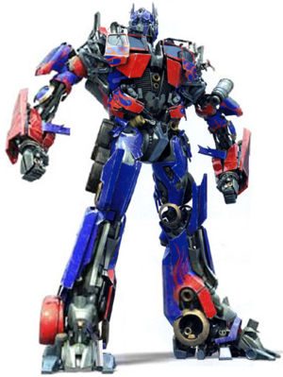

Draw the translation of Triangle XYZ nine units to the right and three units up. Label your new triangle X’Y’Z’.

What are the coordinates of X’?

__________

**Example 3:** Translation By Ordered Pair

The chart below shows the coordinates for the vertices of Triangle ABC. Triangle ABC undergoes a translation of 5 units up and 1 unit to the right, resulting in Triangle A’B’C’. What are the coordinates of the vertices for new triangle?

|  |  |
| --- | --- |
| **Triangle ABC** | **Triangle A’B’C’** |
| A: (3, 4) | A’: |
| B: (0, 2) | B’: |
| C: (1, 7) | C’: |

What quadrant would the triangle be in? _______________________________

**You Try 3!**

The chart below shows the coordinates for the vertices of triangle TUV. Triangle TUV undergoes a translation of 4 units to the left and 6 units up, resulting in Triangle T’U’V’. What are the coordinates of the vertices for new triangle?

|  |  |
| --- | --- |
| **Triangle TUV** | **Triangle T’U’V’** |
| T: (2, 3) | T’: |
| U: (4, -3) | U’: |
| V: (-4, 0) | V’: |

What quadrant would the triangle be in? _______________________________

What are some common **BLUNDERS** on these types of problems?

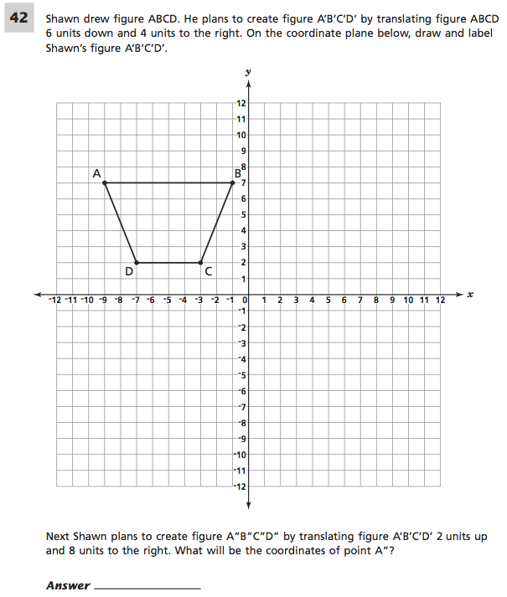

**Independent Practice**

**2.**

**1.**

Description of translation: _____________________

F: _______ F’: _______

G: _______ G’: _______

H: _______ H’: _______

I: _______ I’: _______

Description of translation: _____________________

X: _______ X’: _______

Y: _______ Y’: _______

Z: _______ Z’: _______



**-1**

**-2**

**-3**

**-4**

**-5**

**-6**

**-7**

**-8**

**-9**

**-9 -8 -7 -6 -5 -4 -3 -2 -1 0 1 2 3 4 5 6 7 8 9**

*y-axis*

*x-axis*

**F’**

**G’**

**H’**

**I’**

**F**

**G**

**H**

**I**



**-1**

**-2**

**-3**

**-4**

**-5**

**-6**

**-7**

**-8**

**-9**

**-9 -8 -7 -6 -5 -4 -3 -2 -1 0 1 2 3 4 5 6 7 8 9**

*y-axis*

*x-axis*

**Y**

**Z**

**X**

**Y’**

**Z’**

**X’**

**4.**

**3.**

Description of translation: _____________________

A: _______ A’: _______

B: _______ B’: _______

C: _______ C’: _______

D: _______ D’: _______

Description of translation: _____________________

J: _______ J’: _______

K: _______ K’: _______

L: _______ L’: _______



**-1**

**-2**

**-3**

**-4**

**-5**

**-6**

**-7**

**-8**

**-9**

**-9 -8 -7 -6 -5 -4 -3 -2 -1 0 1 2 3 4 5 6 7 8 9**

*y-axis*

**K’**

**J’**

**L’**

*x-axis*

**K**

**J**

**L**



**-1**

**-2**

**-3**

**-4**

**-5**

**-6**

**-7**

**-8**

**-9**

**-9 -8 -7 -6 -5 -4 -3 -2 -1 0 1 2 3 4 5 6 7 8 9**

**A**

**B**

**C**

**D**

*y-axis*

*x-axis*

**A’**

**B’**

**C’**

**D’**



**-1**

**-2**

**-3**

**-4**

**-5**

**-6**

**-7**

**-8**

**-9**

**-9 -8 -7 -6 -5 -4 -3 -2 -1 0 1 2 3 4 5 6 7 8 9**

*y-axis*

*x-axis*

**X**

**Y**

**Z**



**-1**

**-2**

**-3**

**-4**

**-5**

**-6**

**-7**

**-8**

**-9**

**-9 -8 -7 -6 -5 -4 -3 -2 -1 0 1 2 3 4 5 6 7 8 9**

**A**

**B**

**C**

**D**

*y-axis*

*x-axis*



**-1**

**-2**

**-3**

**-4**

**-5**

**-6**

**-7**

**-8**

**-9**

**-9 -8 -7 -6 -5 -4 -3 -2 -1 0 1 2 3 4 5 6 7 8 9**

*y-axis*

*x-axis*

**K**

**J**

**L**



**-1**

**-2**

**-3**

**-4**

**-5**

**-6**

**-7**

**-8**

**-9**

**-9 -8 -7 -6 -5 -4 -3 -2 -1 0 1 2 3 4 5 6 7 8 9**

*y-axis*

*x-axis*

**P**

**M**

**N**

**O**

Draw the translation of Triangle JKL six units to the left. Label your new triangle J’K’L’.

What are the coordinates of K’? __________

Draw the translation of Quadrilateral MNOP seven units to the right. Label your new figure M’N’O’P’.

What are the coordinates of P’? __________

Draw the translation of Triangle XYZ three units to the left. Label your new triangle X’Y’Z’.

What are the coordinates of X’? __________

Draw the translation of Rectangle ABCD seven units down. Label your new rectangle A’B’C’D’.

What are the coordinates of C’? __________

**7.**

**6.**

**5.**

**8.**

**10.**

**9.**

The chart below shows the coordinates for the vertices of Triangle JKL. Triangle JKL undergoes a translation of 1 unit to the right and 1 unit up, resulting in Triangle J’K’L’. What are the coordinates of the vertices for new triangle?

|  |  |
| --- | --- |
| **Triangle JKL** | **Triangle J’K’L’** |
| J: (2, 5) | J’: |
| K: (-4, -2) | K’: |
| L: (0, 9) | L’: |

The chart below shows the coordinates for the vertices of triangle QRS. Triangle QRS undergoes a translation of 5 units to the left, resulting in Triangle Q’R’S’. What are the coordinates of the vertices for new triangle?

|  |  |
| --- | --- |
| **Triangle QRS** | **Triangle Q’R’S’** |
| Q: (6, 9) | Q’: |
| R: (1, 4) | R’: |
| S: (5, -3) | S’: |

**12.**

**11.**

The chart below shows the coordinates for the vertices of Quadrilateral MNOP. Quadrilateral MNOP undergoes a translation of 3 units to the right and 2 units down, resulting in Quadrilateral M’N’O’P’. What are the coordinates of the vertices for new quadrilateral?

|  |  |
| --- | --- |
| **Quadrilateral DEFG** | **Quadrilateral D’E’F’G’** |
| M: (7, -1) | M’: |
| N: (3, -4) | N’: |
| O: (-5, 2) | O’: |
| P: (-1,5) | P’: |

Triangle XYZ undergoes a translation of 4 units to the left and 3 units up, resulting in Triangle X’Y’Z’. The chart below shows the coordinates for the vertices of the **new** triangle. What are the coordinates of the vertices for the **original** triangle?

|  |  |
| --- | --- |
| **Triangle XYZ** | **Triangle X’Y’Z’** |
| Q: | Q’: (2, 7) |
| R: | R’: (-1, 0) |
| S: | S’: (-5, 3) |

**Homework:** WB pg. 114 all

**Exit Ticket**

The chart below shows the coordinates for the vertices of Quadrilateral DEFG. Quadrilateral DEFG undergoes a translation of 2 units to the right, resulting in Quadrilateral D’E’F’G’. What are the coordinates of the vertices for new quadrilateral?

|  |  |
| --- | --- |
| **Quadrilateral DEFG** | **Quadrilateral D’E’F’G’** |
| D: (1, 2) | D’: |
| E: (6, 3) | E’: |
| F: (2, 5) | F’: |
| G: (8, 6) | G’: |