Name________________________
GH Warm-Up 9.3 & 9.4
9.3
9.4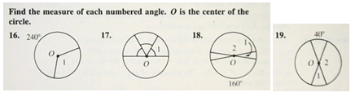
2.
4.
3.
1.
