Name________________________ Date________________________
Exploring Inscribed Angles!
Here are some definitions to help you get started:
Inscribed Angle – an angle whose vertex is on a circle and whose sides contain chords of the circle
Intercepted Arc – the arc that is in the interior of the inscribed angle
Figure 1. Angles 1 and 2 are inscribed angles. The red parts of the circles are called intercepted arcs.
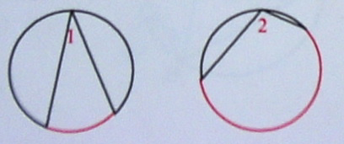
Directions: Based on the pictures below, fill in the blanks for the following theorems.
C
B
B
45°
30°
50°
100
B
A
90
C
A
A
60
C
Theorem 9.7: The measure of an inscribed angle is equal to ________ the measure of its intercepted arc.
2
Angles 1 and 2 are congruent in all 3 figures.
B
B
A
A
2
1
1
A
C
C
2
1
D
D
D
B
C
Name the arc that angles 1
and 2 have in common __________.
Name the arc that angles 1
and 2 have in common __________.
Name the arc that angles 1
and 2 have in common __________.

Corollary 1: If two inscribed angles _______________ the same arc, then the angles are _____________.
Arcs ABC are semicircles in all 3 figures.
B
C
B
A
90°
C
B
A
90°
90°
C
A

Corollary 2: An angle inscribed in a semicircle is a ________ angle.
95°
105°
110°
130°
G
G
G
H
H
H
90°
70°
80°
85°
75°
F
50°
F
F
E
E
E
90°
100°

Corollary 3: If a quadrilateral is inscribed in a circle, then its opposite angles are ____________________. (Hint: What do angles H and F add up to? Angles E and G?)
T
A
Segment PT is tangent to the circle in the following 3 figures.
100
80°
P
A
150
P
160
50°
T
75°
P
T
A

Theorem 9.8: The measure of an angle formed by a __________ and a _____________ is equal to __________ the measure of the intercepted arc. (Hint: What is the relationship between angle ATP and minor arc AT?)

