Graphing Linear Equations Unit Test Name ________________________
Algebra I

Multiple Choice & Gridded Response – Choose the correct answer for each question. No partial credit will be given. Make sure your answer choice is marked clearly for each question. It is to your benefit to answer each question.
Use the graph of the line below to answer questions #1-3.

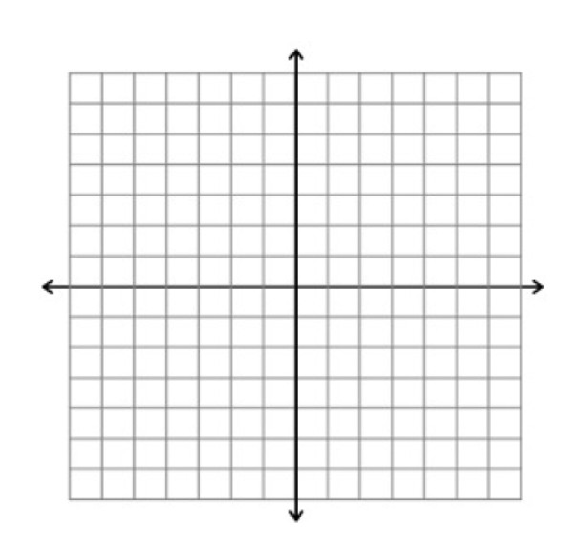
- Gridded response – What is the y-intercept of this line?

- The slope is:
  - positive
  - negative
  - zero
  - undefined

- What is the equation of this line in slope-intercept form?
  - y = -½x + 2
  - y = -½x + 1
  - y = ½x + 2
  - y = ½x + 1

- Gridded response - What is the slope of the line that passes through the points (-3,7) and (-9,4)?

- Gridded response - What is the x-intercept of the line 6x + y = 18?

- What is y – 4 = 3(x + 1) in standard form?
  - -3x + y = 5
  - -3x + y = 7
  - 3x - y = -7
  - 3x - y = 7

Use the graph below to answer questions #7 - 9.
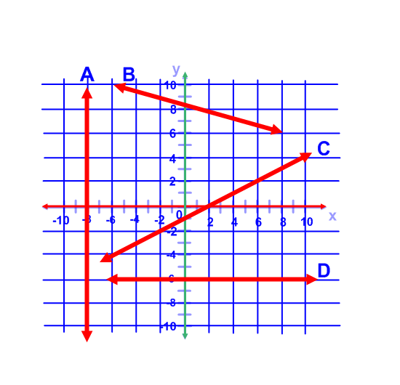
- Which line above has a slope of zero?
  - Line A
  - Line B
  - Line C
  - Line D

- Which line above has an undefined slope?
  - Line A
  - Line B
  - Line C
  - Line D

- Which line has a positive slope?
  - Line A
  - Line B
  - Line C
d. Line D

- The line y = -7 is:
  - Horizontal
  - Vertical
  - Neither
  - Cannot be determined

- The line x = 5 is:
  - Horizontal
  - Vertical
  - Neither
  - Cannot be determined

- Which equation is written in slope-intercept form?
  - y – 4 = 3(x – 5)
  - y – 4 = 3x – 5
  - 3x – y = -11
  - y = 3x – 11

- Which equation is written in point-slope form?
  - y – 2 = 9(x + 2)
  - y – 2 = 9x + 2
  - 9x – y = -20
  - y = 9x – 20

- What is the equation of the line in point-slope form containing the points (4, -1) and (10, 0)?
  - y – 1 = 1/6(x – 4)
  - y = 1/6(x – 10)
  - y = 1/6x – 5/3
  - y + 0 = -1/6(x + 10)

- Which graph shows the equation y = x + 4?
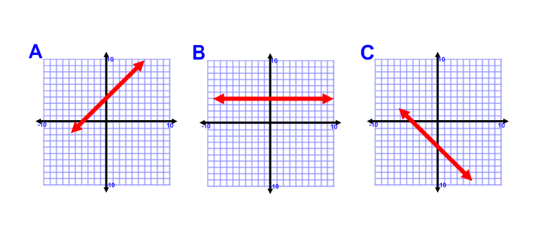
**Bonus** - These questions are not required. You may skip these. Partial credit will be given.
- What pieces of information do you need to write an equation of a line in slope-intercept form?

- What information do you need to write an equation in point-slope form?

- You start a lawn mowing service. You pay $75 for the lawn mower and plan on charging $25 per lawn. Write an equation to relate your income y to the number of lawns you mow x.

- A line has an x-intercept of 4 and y-intercept of 7.
  - What is the slope of this line?
  - Write an equation in slope intercept form for the line.
  - Write an equation in point-slope form.

- Graph y = -4/3x + 7

