3-1 & 3-3 Quiz Name: ______________________________
Directions: Show your work for each step. You can receive partial credit so it is important to show each step.
1. Put the linear equation in standard form. 2. Find the x- and y- intercepts of 7y = x + 21.
4y = 16x + 8

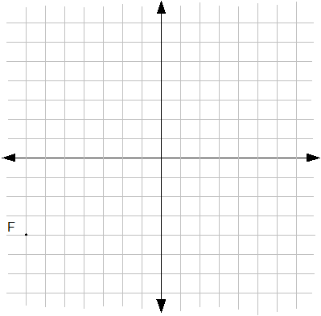
3. a) Graph 3y = -2x - 6 using the x- and y- intercepts.

b) Is the slope of the line you graphed: positive, negative, zero or undefined?

c) Find the rate of change of the line you graphed using the slope equation and 2 points on the line.
Remember: $m= \frac{y_{2}- y_{1}}{x_{2}- x_{1}}$

4. Label each line as having a slope that is either: positive, negative, zero or undefined.

