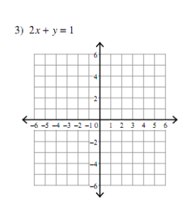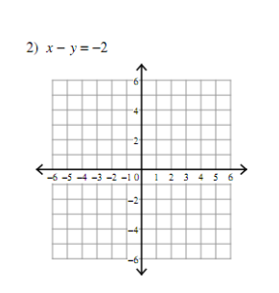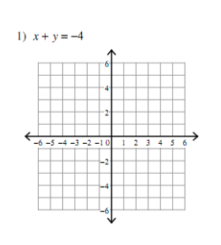

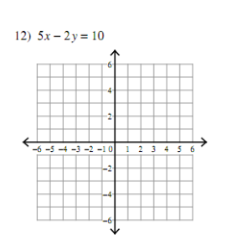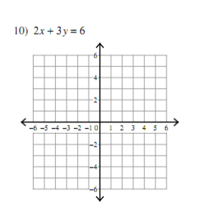

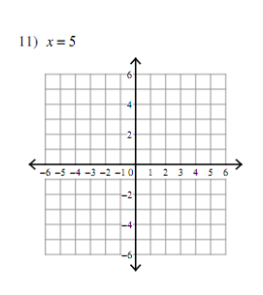

**3-1 Graphing Linear Equations Using Intercepts** Name:_________________________________

Show the steps you take to find each intercept then graph the line.



