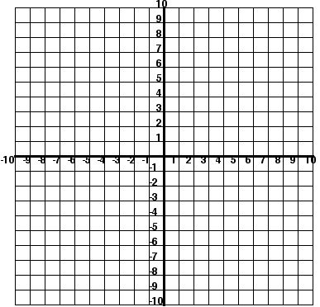
Graph the system of inequalities.
x - 5y > - 15
5y ≥ x - 5

Graph the system of inequalities.
x - 5y > - 15
5y ≥ x - 5

